1)Deploy an application using a Deployment with 3 replicas and a rolling update strategy.

Step 1: Check Cluster is Ready
On your master server, run:
kubectl get nodes
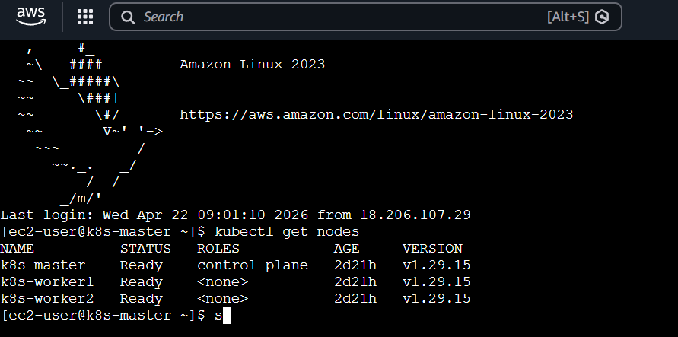
You should see your master (and workers if added)

Step 2: Create Deployment YAML
Create a file:
vi deployment.yaml

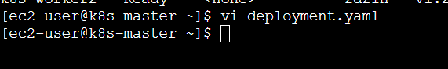
Paste this:

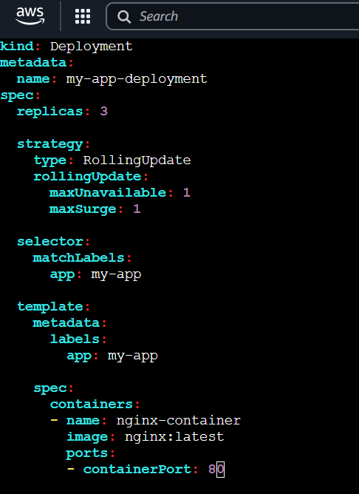
apiVersion: apps/v1
kind: Deployment
metadata:
name: my-app-deployment
spec:
replicas: 3
strategy:
type: RollingUpdate
rollingUpdate:
maxUnavailable: 1
maxSurge: 1
selector:
matchLabels:
app: my-app
template:
metadata:
labels:
app: my-app
spec:
containers:
- name: nginx-container
image: nginx:latest
ports:
- containerPort: 80

Step 3: Apply Deployment
kubectl apply -f deployment.yaml

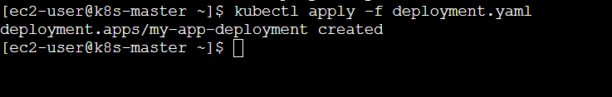

Step 4: Verify Deployment
Check deployment:
kubectl get deployments

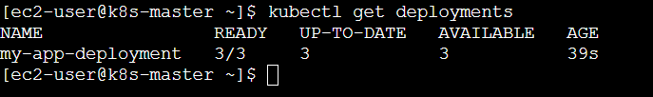
Check pods:
kubectl get pods -o wide

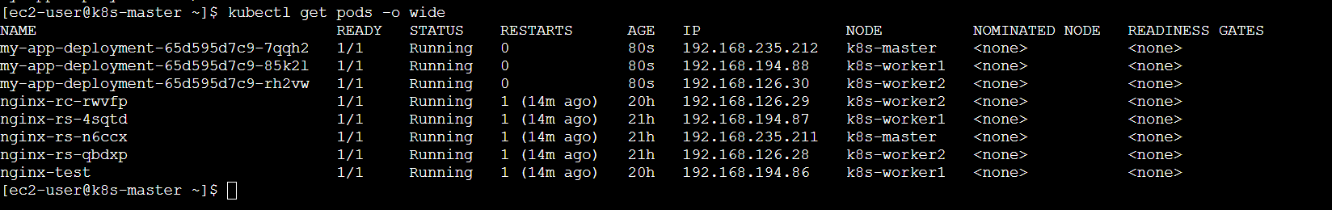
You should see 3 pods running

Step 5: Check Rolling Update Strategy
kubectl describe deployment my-app-deployment

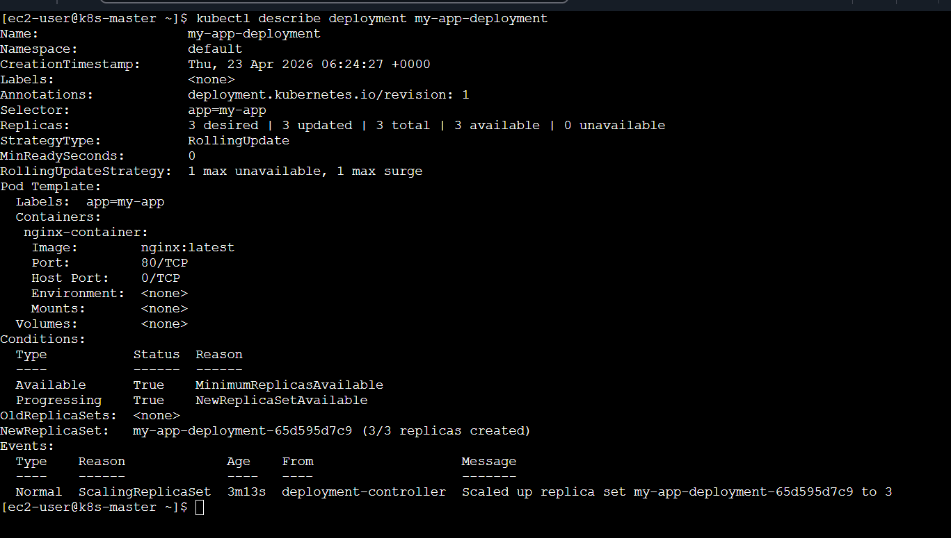
Look for:
StrategyType: RollingUpdate
MaxUnavailable: 1
MaxSurge: 1

Step 6: Perform Rolling Update
Now update the image to simulate deployment update:
kubectl set image deployment/my-app-deployment nginx-container=nginx:1.25

Step 7: Watch Rolling Update Live
kubectl rollout status deployment my-app-deployment
OR watch pods:
kubectl get pods -w

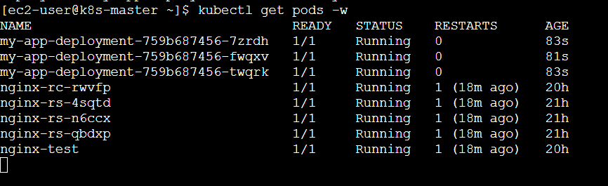
You’ll see:
- Old pods terminate one by one
- New pods created gradually
This is rolling update in action

Step 8: Rollback (if needed)
kubectl rollout undo deployment my-app-deployment

Step 9: Check Rollout History
kubectl rollout history deployment my-app-deployment

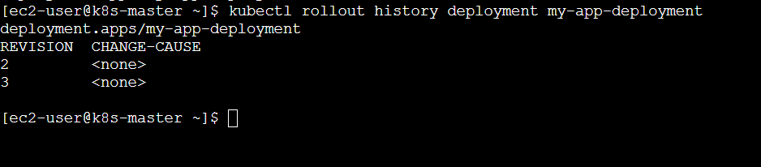

Quick Understanding
- replicas: 3 → ensures high availability
- maxUnavailable: 1 → only 1 pod can go down
- maxSurge: 1 → 1 extra pod can be created
- RollingUpdate → zero downtime deployment

2) Configure a Deployment with a Recreate strategy and observe the downtime.

Step 1: Create Deployment with Recreate Strategy
Create file:
vi recreate-deployment.yaml

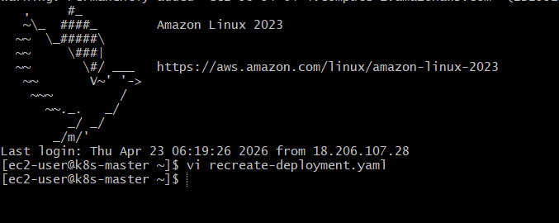
Paste this:
apiVersion: apps/v1
kind: Deployment
metadata:
name: recreate-app
spec:
replicas: 3
strategy:
type: Recreate # Important
selector:
matchLabels:
app: recreate-app
template:
metadata:
labels:
app: recreate-app
spec:
containers:
- name: nginx
image: nginx:1.24
ports:
- containerPort: 80
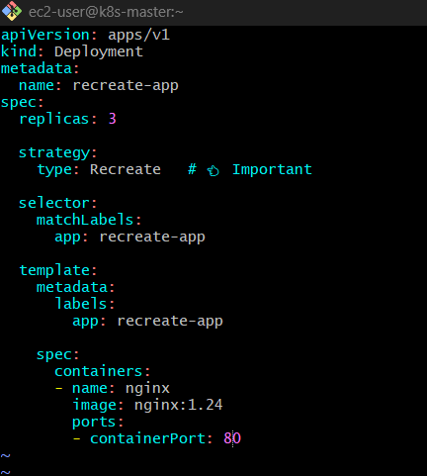

Step 2: Apply Deployment
kubectl apply -f recreate-deployment.yaml

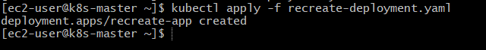

Step 3: Verify Pods
kubectl get pods -o wide
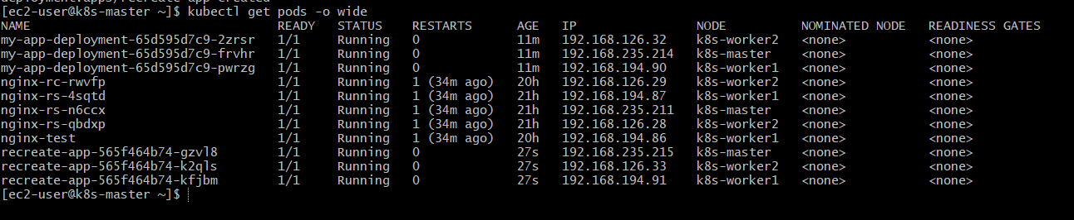
You’ll see 3 running pods

Step 4: Expose Deployment (Important to see downtime)
kubectl expose deployment recreate-app --type=NodePort --port=80

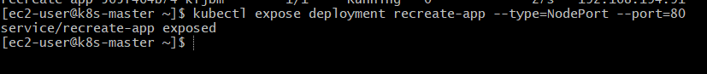
Check service:
kubectl get svc

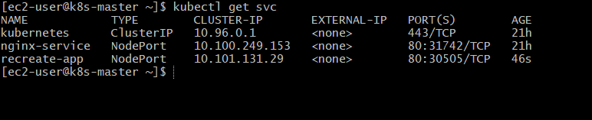
Note the NodePort (example: 30007)

Step 5: Access Application
Open in browser:
http://<NodeIP>:<NodePort>
http://98.94.64.4:30505/

You should see NGINX welcome page
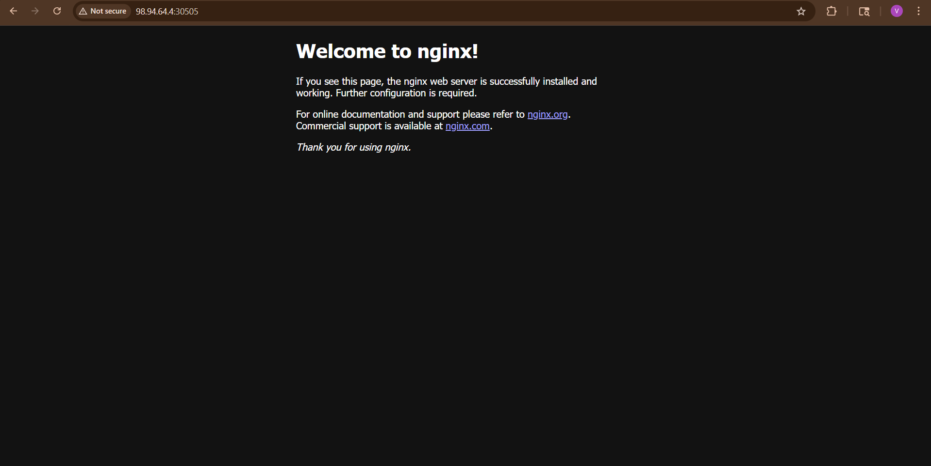

OR curl:
curl http://<NodeIP>:<NodePort>
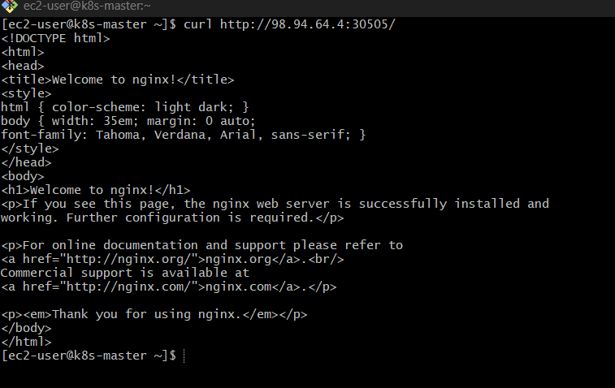

Step 6: Start Watching Pods (Live)
Open another terminal:
kubectl get pods -w
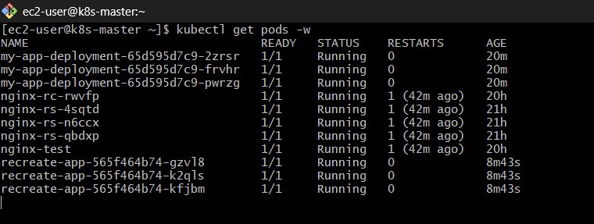

Step 7: Trigger Update (THIS IS WHERE MAGIC HAPPENS)
kubectl set image deployment/recreate-app nginx=nginx:1.25

Step 8: Observe Downtime
Watch carefully:
What happens:
- ALL old pods terminate first ❌
- Then new pods are created ✅
During this time:
Try curl again:
curl http://<NodeIP>:<NodePort>
You will get:
- Connection refused OR
- Timeout
That is DOWNTIME

What Just Happened?
Recreate Strategy =
- Delete all old pods first
- Then create new ones
So:
- No pods = No service = ❌ downtime

Recreate vs RollingUpdate (Important)
Feature | Recreate | RollingUpdate
Downtime | ❌ Yes | ✅ No
Update speed | Fast | Gradual
Use case | DB apps, breaking changes | Web apps

3)Update an existing Deployment and perform a rollback to the previous version.

Scenario
You already have a Deployment (example: my-app-deployment) running.
We will:
- Update the image
- Verify rollout
- Rollback to previous version

Step 1: Check Existing Deployment
kubectl get deployments
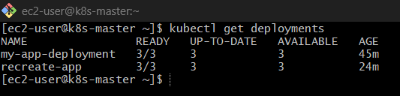
kubectl describe deployment my-app-deployment

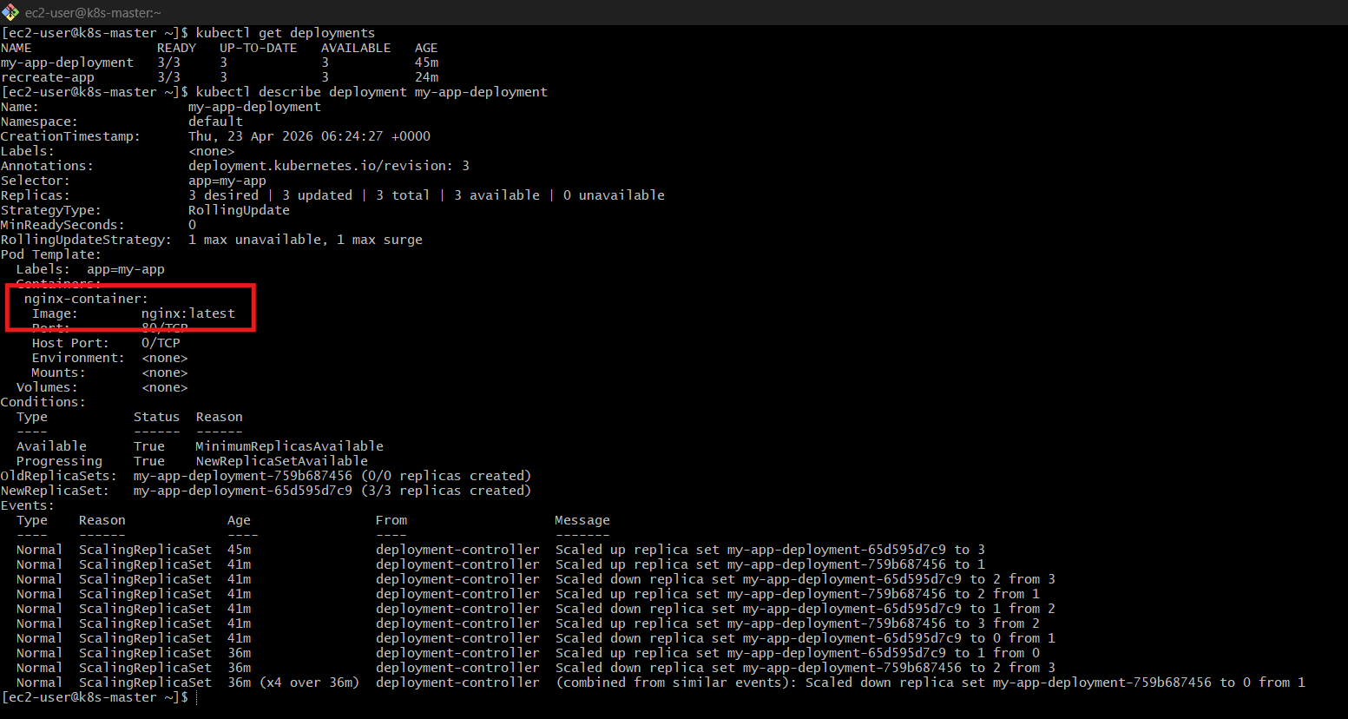
Note current image (example: nginx:1.24)

Step 2: Update Deployment (New Version)
kubectl set image deployment/my-app-deployment nginx-container=nginx:1.25

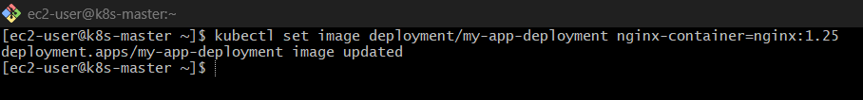

Step 3: Watch Rollout
kubectl rollout status deployment my-app-deployment

OR live view:
kubectl get pods -w

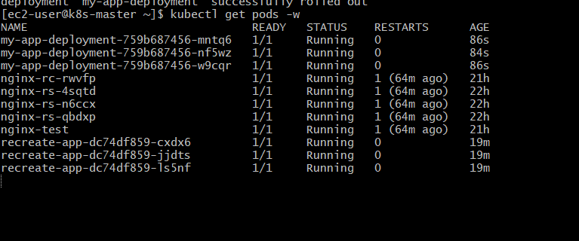
Pods will update gradually (RollingUpdate)

Step 4: Check Rollout History
kubectl rollout history deployment my-app-deployment
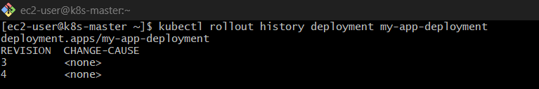
Output example:
REVISION CHANGE-CAUSE
1 nginx:1.24
2 nginx:1.25
Update with Change Cause
kubectl set image deployment/my-app-deployment nginx-container=nginx:1.26
Now add annotation:
kubectl annotate deployment my-app-deployment \
kubernetes.io/change-cause="Updated nginx to 1.26"

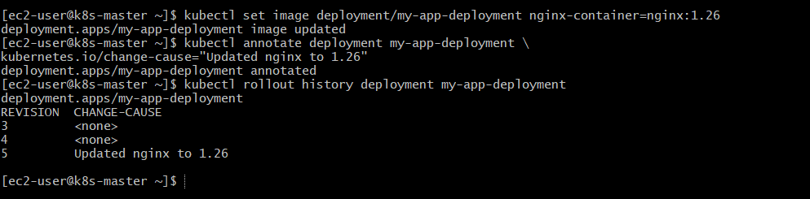

Step 5: Simulate Issue (Optional but Important)
Let’s assume new version is bad bm jj/l;/k
(you can even try wrong image to simulate failure)

Step 6: Rollback to Previous Version
kubectl rollout undo deployment my-app-deployment

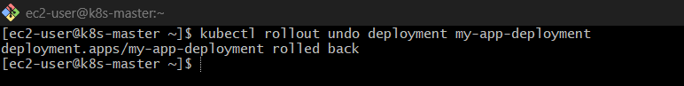

Step 7: Verify Rollback
kubectl rollout status deployment my-app-deployment

Check pods:
kubectl get pods

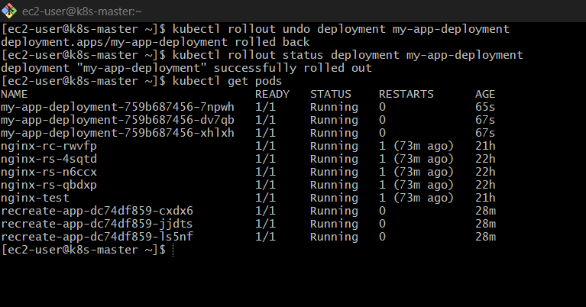
Pods should now run old image (nginx:1.25)

Step 8: Confirm Image Version
kubectl describe deployment my-app-deployment | grep Image

Check ReplicaSets
Run:
kubectl get rs

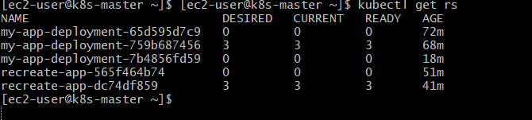
You’ll see something like:
my-app-deployment-xxxx 3 replicas ← current
my-app-deployment-yyyy 0 replicas ← old
These ReplicaSets = your revisions
From your output:
my-app-deployment-65d595d7c9 0 pods ← OLD version
my-app-deployment-759b687456 3 pods ← CURRENT version ✅
my-app-deployment-7b4856fd59 0 pods ← PREVIOUS version
Important:
- Current RS → 759b687456 (nginx:1.25)
- Old RS → 7b4856fd59 (previous version)
- Very old RS → 65d595d7c9 (older version)

Step 9: Rollback to Specific Revision
kubectl rollout undo deployment my-app-deployment --to-revision=1
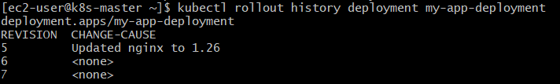
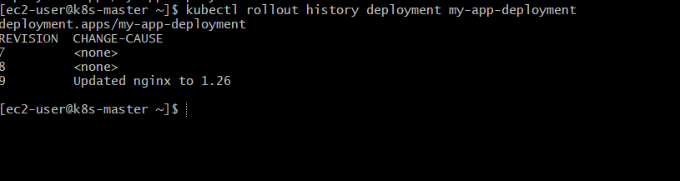

What’s Happening Internally?
- Kubernetes keeps ReplicaSet history
- Each update = new revision
- Rollback = switch back to old ReplicaSet

4) Modify a Deployment to add resource requests and limits for CPU and memory.

What We’re Adding
- requests → minimum guaranteed
- limits → maximum allowed

Step 1: Edit Deployment
kubectl edit deployment my-app-deployment
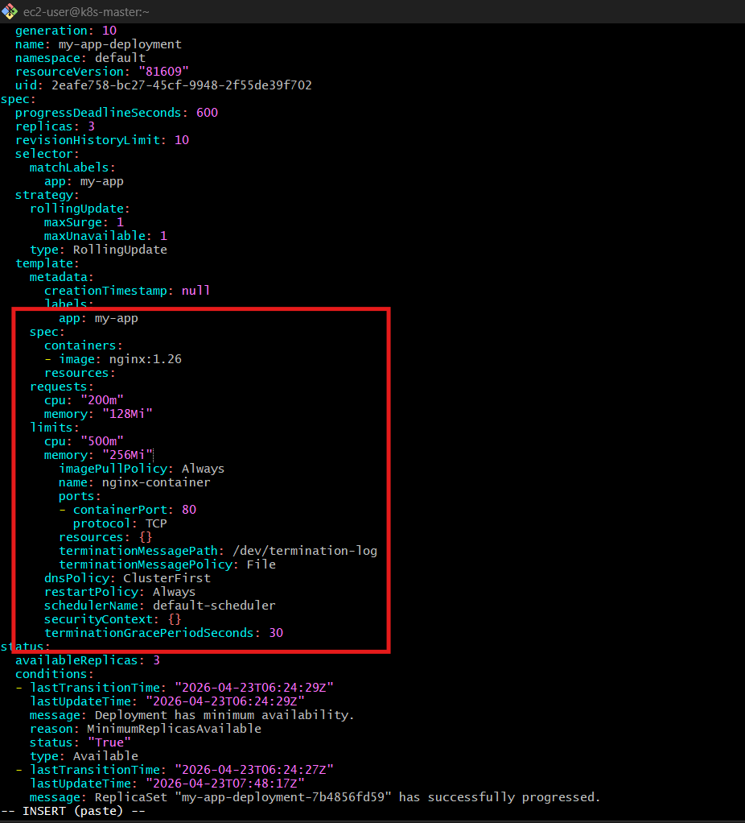

Step 2: Add Resources Section
Inside the container block, update like this
spec:
template:
spec:
containers:
- name: nginx-container
image: nginx:1.25
resources:
requests:
cpu: "200m"
memory: "128Mi"
limits:
cpu: "500m"
memory: "256Mi"
Save and exit (:wq)

Step 3: Rolling Update Happens Automatically
Check:
kubectl get pods -w

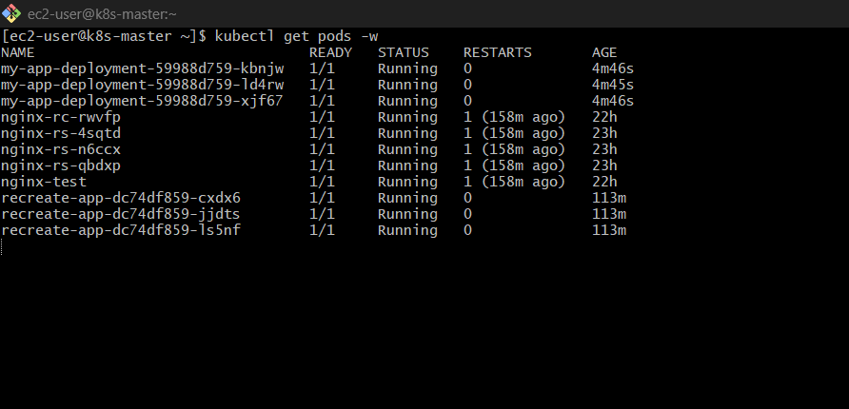
Old pods terminate → new pods created with resources

Step 4: Verify Resources
kubectl describe pod <pod-name>
kubectl describe pod my-app-deployment-59988d759-kbnjw

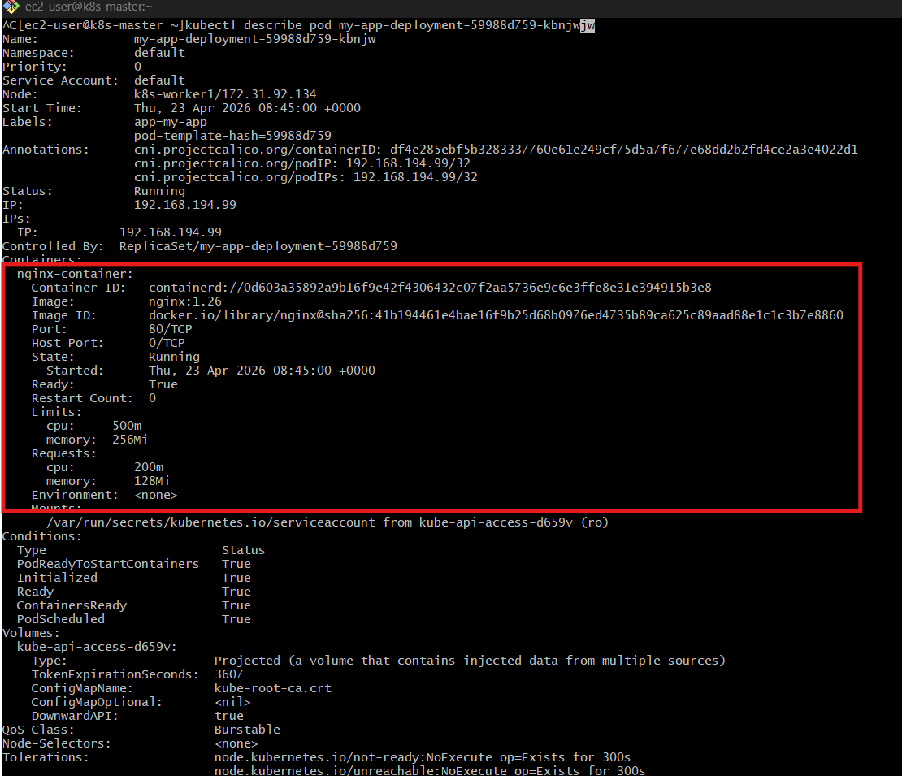
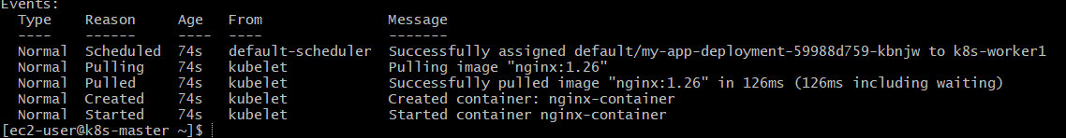
Look for:
Requests:
cpu: 200m
memory: 128Mi
Limits:
cpu: 500m
memory: 256Mi

Alternative (Direct YAML Apply)
Just run patch command:

kubectl patch deployment my-app-deployment \
--type='json' \
-p='[
{
"op": "add",
"path": "/spec/template/spec/containers/0/resources",
"value": {
"requests": {
"cpu": "200m",
"memory": "128Mi"
},
"limits": {
"cpu": "500m",
"memory": "256Mi"
}
}
}
]'

Verify
kubectl describe pod <pod-name>
You should see:
Requests:
cpu: 200m
Limits:
cpu: 500m

Bonus Check (Optional)
kubectl top pods

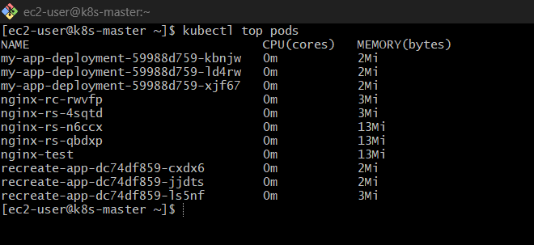
Shows actual CPU & memory usage (if metrics-server installed)

Important Behavior
- If pod uses more than 500m CPU → throttled
- If memory > 256Mi → pod killed (OOMKilled)

5) Create a Deployment with MaxSurge and MaxUnavailable configurations.

Let’s create a Deployment with:
- maxSurge
- maxUnavailable
step-by-step from scratch

Quick Concept (Must Know)
maxSurge = extra pods allowed during update
maxUnavailable = pods that can go down
Example:
- replicas = 3
- maxSurge = 1 → can go up to 4 pods
- maxUnavailable = 1 → at least 2 pods always running

Step 1: Create YAML File
vi surge-deployment.yaml

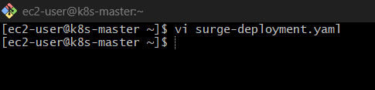

Step 2: Paste This YAML
apiVersion: apps/v1
kind: Deployment
metadata:
name: surge-app
spec:
replicas: 3
strategy:
type: RollingUpdate
rollingUpdate:
maxSurge: 1
maxUnavailable: 1
selector:
matchLabels:
app: surge-app
template:
metadata:
labels:
app: surge-app
spec:
containers:
- name: nginx
image: nginx:1.24
ports:
- containerPort: 80
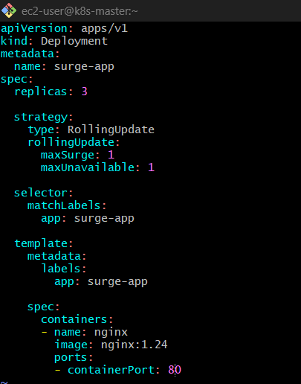

Step 3: Apply Deployment
kubectl apply -f surge-deployment.yaml

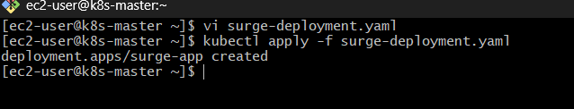

Step 4: Verify
kubectl get deployments

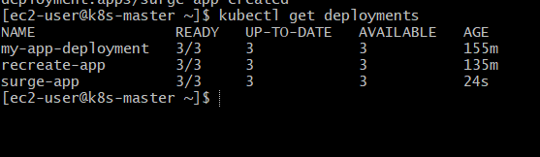
kubectl get pods

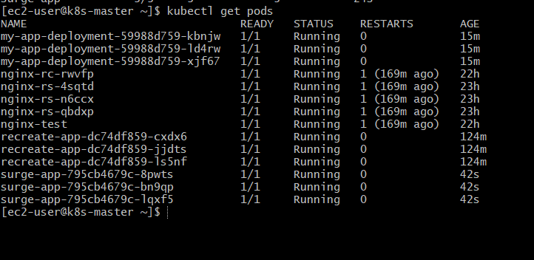
You should see 3 pods running

Step 5: Trigger Rolling Update
kubectl set image deployment/surge-app nginx=nginx:1.25

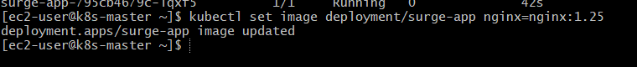

Step 6: Observe Behavior
kubectl get pods -w

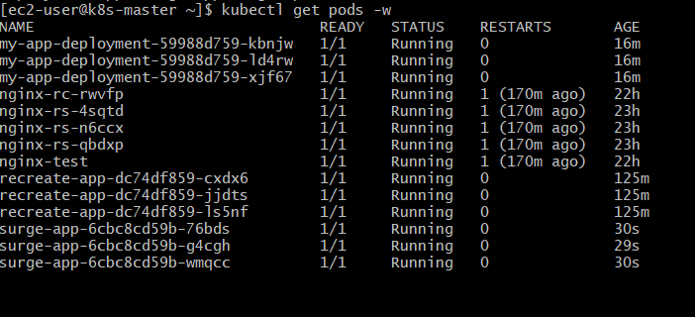

You’ll notice:
- New pod created first (total = 4)
- One old pod deleted ❌
- Process continues
That’s maxSurge in action

Expected Flow
Step |  | Pods
Start |  | 3
Surge |  | 4 (1 extra)
Replace |  | 3
Complete |  | 3
What If Values Change?
Setting |  | Effect
maxSurge: 0 |  | No extra pods
maxUnavailable: 2 |  | More downtime risk
both 0 |  | ❌ Invalid

6) Set up a Deployment with a custom revision history limit.

What is revisionHistoryLimit?
It controls how many old ReplicaSets (versions) are stored
Example:
- revisionHistoryLimit: 5
→ Kubernetes keeps last 5 revisions only
Older ones get deleted automatically

Step 1: Create YAML File
vi revision-deployment.yaml

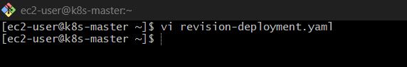

Step 2: Paste This YAML
apiVersion: apps/v1
kind: Deployment
metadata:
name: revision-app
spec:
replicas: 3
revisionHistoryLimit: 5 # Custom limit
strategy:
type: RollingUpdate
rollingUpdate:
maxSurge: 1
maxUnavailable: 1
selector:
matchLabels:
app: revision-app
template:
metadata:
labels:
app: revision-app
spec:
containers:
- name: nginx
image: nginx:1.24
ports:
- containerPort: 80
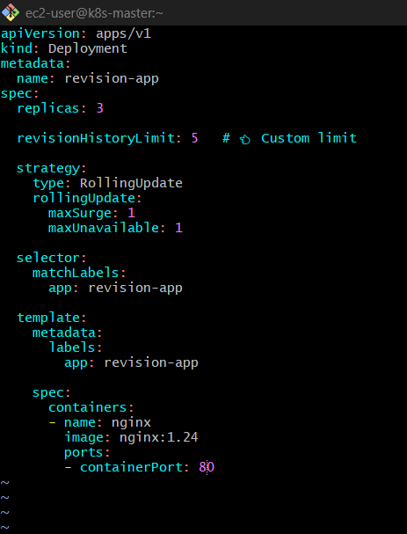

Step 3: Apply Deployment
kubectl apply -f revision-deployment.yaml

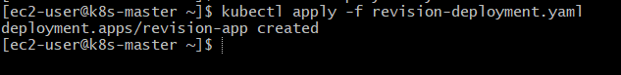

Step 4: Verify Deployment
kubectl get deployment revision-app

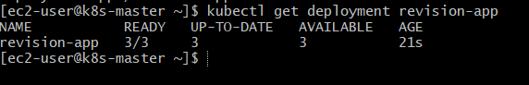

Step 5: Create Multiple Revisions
Update image multiple times:
kubectl set image deployment/revision-app nginx=nginx:1.25
kubectl set image deployment/revision-app nginx=nginx:1.26
kubectl set image deployment/revision-app nginx=nginx:1.27
kubectl set image deployment/revision-app nginx=nginx:1.28
kubectl set image deployment/revision-app nginx=nginx:1.29
kubectl set image deployment/revision-app nginx=nginx:1.30

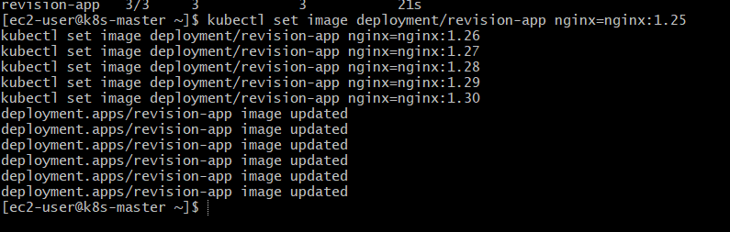

Step 6: Check ReplicaSets
kubectl get rs

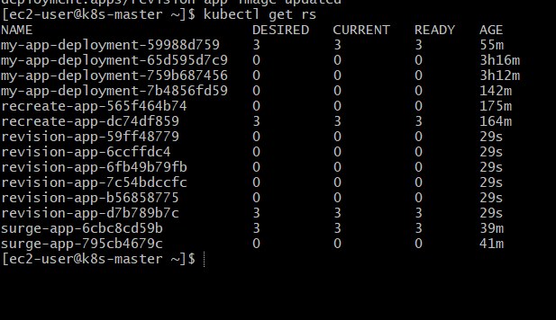
You’ll notice:
- Only 5 old ReplicaSets kept
- Older ones automatically deleted

Step 7: Check Rollout History
kubectl rollout history deployment revision-app

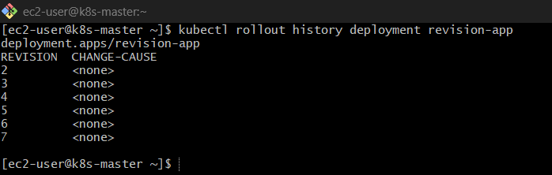
Shows only last 5 revisions

ReplicaSets for revision-app
revision-app-59ff48779 0 pods
revision-app-6ccffdc4 0 pods
revision-app-6fb49b79fb 0 pods
revision-app-7c54bdccfc 0 pods
revision-app-b56858775 0 pods
revision-app-d7b789b7c 3 pods ✅ (ACTIVE)

Real Behavior
Setting |  | Result
revisionHistoryLimit: 1 |  | Only last version kept
revisionHistoryLimit: 0 |  | ❌ No rollback possible
revisionHistoryLimit: 5 |  | Balanced (recommended)

7) Pause a Deployment during an update, and then resume it.

What is Pause/Resume?
Pause = stop rollout temporarily
Resume = continue rollout

Useful when:
- You want to apply multiple changes together
- You want to inspect before rollout

Step 1: Check Deployment
kubectl get deployment my-app-deployment

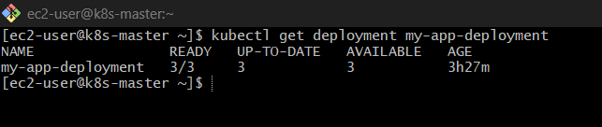
Step 2: Pause the Deployment
kubectl rollout pause deployment my-app-deployment

Output:
deployment.apps/my-app-deployment paused

Step 3: Verify Paused State
kubectl describe deployment my-app-deployment | grep -i paused

Your Output
Progressing Unknown DeploymentPaused
This means:
Deployment is PAUSED successfully ✅

Step 4: Make Changes While Paused
Now update image:
kubectl set image deployment/my-app-deployment nginx-container=nginx:1.27
IMPORTANT:
Pods will NOT update yet

Step 5: Verify No Changes Happened
kubectl get pods

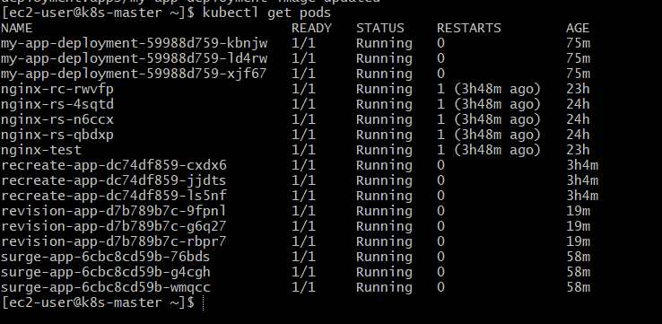
Pods remain same (no rollout)

Step 6: Resume Deployment
kubectl rollout resume deployment my-app-deployment

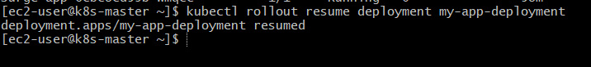
Output:
deployment.apps/my-app-deployment resumed

Step 7: Watch Rollout
kubectl get pods -w

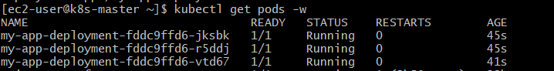
Now:
- Old pods terminate ❌
- New pods create ✅
Rollout resumes

Real Behavior
State |  |  |  |  |  | Behavior
Paused |  |  |  |  |  | No rollout
Resume |  |  |  |  |  | Rollout continues

8) Create a pod using resource requests for memory and CPU, and observe how the scheduler assigns it to a node.

What You’ll Learn
How requests affect scheduling
How Kubernetes chooses a node
How to verify placement

Step 1: Create Pod YAML
vi resource-pod.yaml
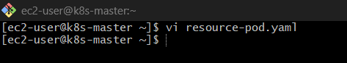

Step 2: Paste This YAML
apiVersion: v1
kind: Pod
metadata:
name: resource-pod
spec:
containers:
- name: nginx
image: nginx:1.25
resources:
requests:
cpu: "250m"
memory: "128Mi"
limits:
cpu: "500m"
memory: "256Mi"
ports:
- containerPort: 80
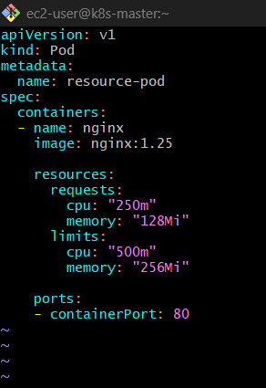

Step 3: Create Pod
kubectl apply -f resource-pod.yaml

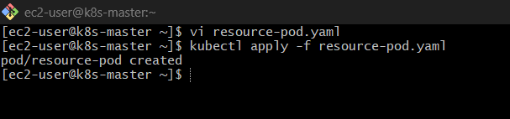

Step 4: Check Pod Status
kubectl get pods -o wide

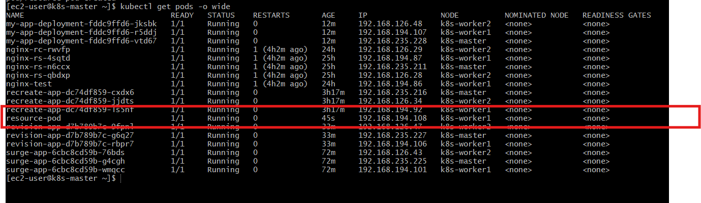
Output will show:
NAME READY STATUS NODE
resource-pod 1/1 Running worker-node-1
NODE column = where scheduler placed pod

How Scheduler Decides
Kubernetes checks:
- Node available CPU
- Node available memory
If node has enough resources → pod scheduled there ✅
If not → pod stays Pending ❌

Step 5: Deep Inspection
kubectl describe pod resource-pod

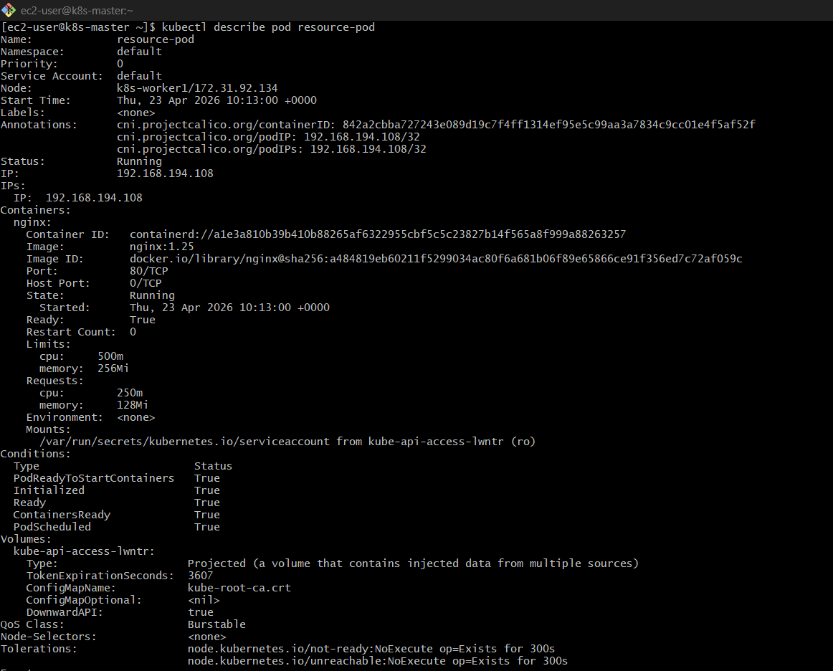
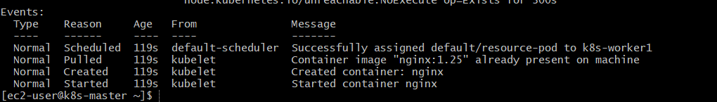
Look for:
Node: k8s-worker1

Step 6: Check Node Capacity
kubectl describe node <node-name>
kubectl describe node k8s-worker1

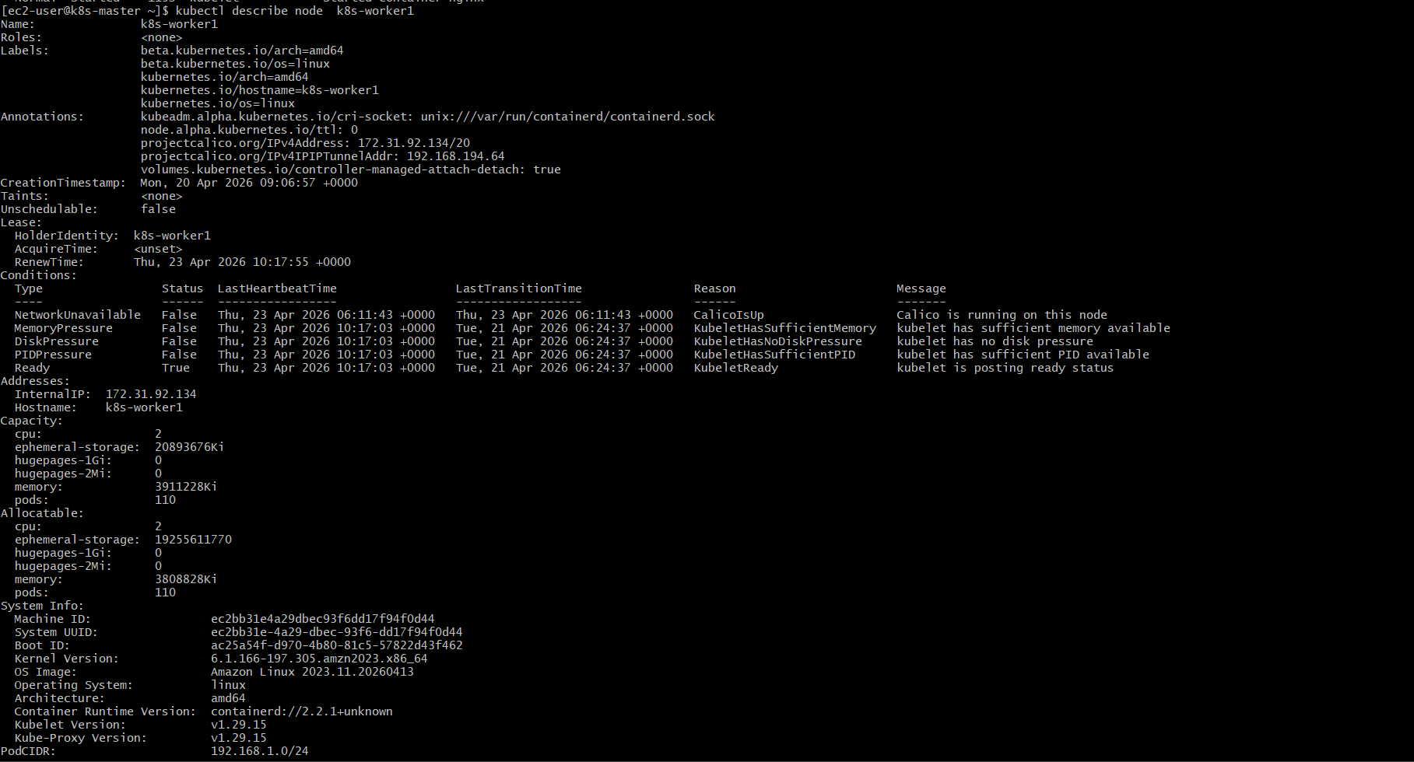
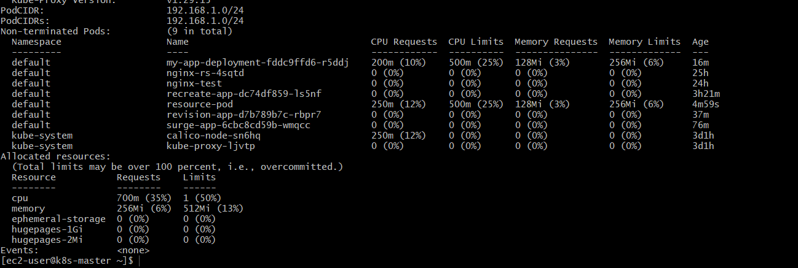

Look for:
Allocated resources:
CPU Requests
Memory Requests

Try This (Very Important Test )
Modify YAML with HIGH request:
requests:
cpu: "5"
memory: "10Gi"
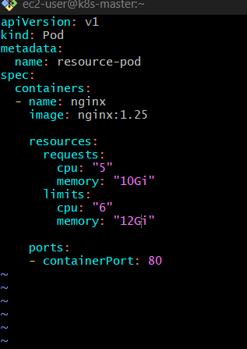
Then apply:
kubectl apply -resource-pod.yaml

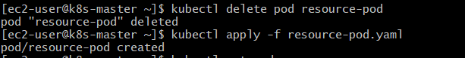
Now check:
kubectl get pods

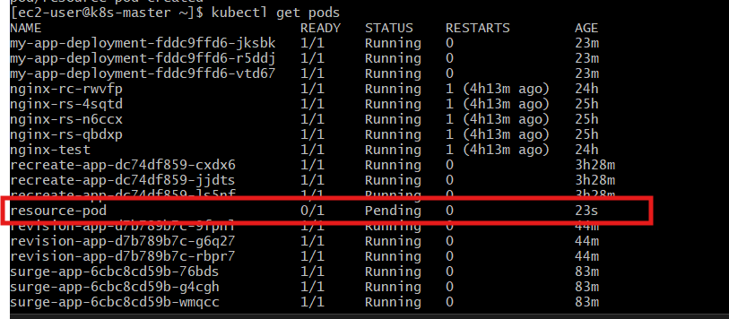
Status = Pending

Why Pending?
Check:
kubectl describe pod resource-pod

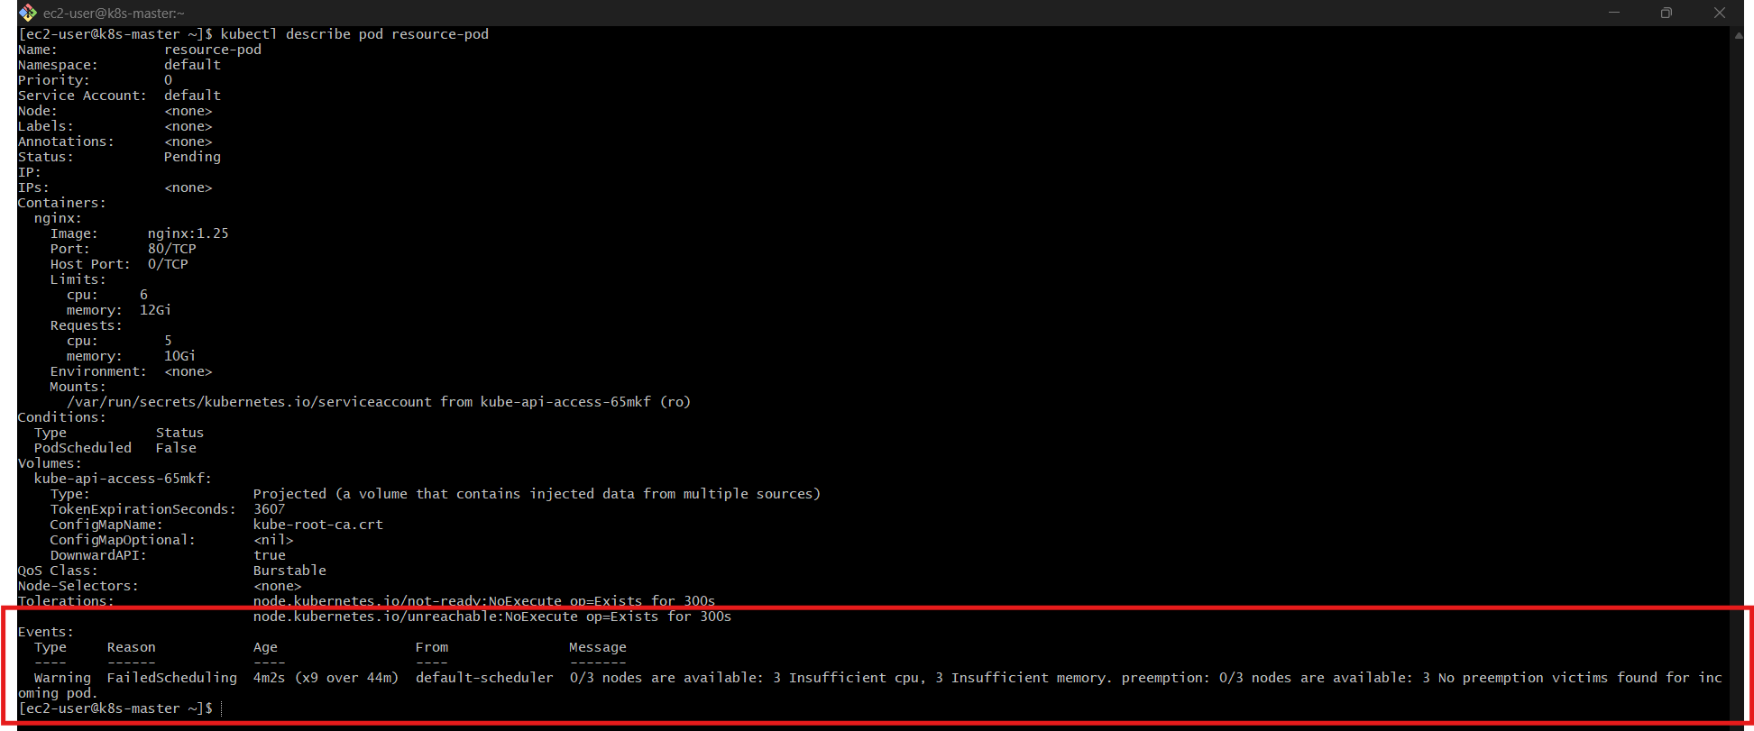

You’ll see:
Insufficient cpu
Insufficient memory

Key Learning
Scenario |  |  | Result
Enough resources |  |  | Pod scheduled ✅
Not enough |  |  | Pending ❌

